ELECTRONIC PRESS KIT

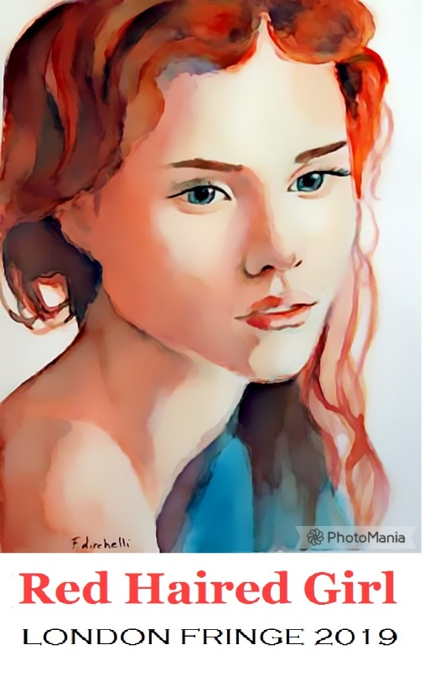

Contacts, What, When, Where, Tickets, Social Media …….…………….…………………. 2
Red Haired Girl Press Release ............................................................................... 3
Full Cast ............................................................................................................... 3
Principal Actor Bios …………..................................................................................... 4
About New Years Resolution Productions ............................................................. 4
Photo Library .......................................................................................................... 5

Contact:
Mitch Moldofsky, Writer-Director
Before Fringe: 416 944 1912  During Fringe: 647 831 0375
mintjello@hotmail.com

CONTACT: Mitch Moldofsky, Writer-Director
EMAIL: mintjello@hotmail.com
PHONE: Before fringe: 416 944 1912 / During fringe: 647 831 0375
PHOTOS: Samples below; download instructions from London Fringe office

FILMMAKER MITCH MOLDOFSKY RETURNS TO THE STAGE
WITH HIS PLAY RED HAIRED GIRL AT THE LONDON FRINGE FESTIVAL

“Funny, relatable and insightful.”
“Tore my heart out.”
Responses from Workshop audience members

WHAT
New Years Resolution Productions presents Toronto native Mitch Moldofsky’s new play Red Haired Girl, directed the author and featuring Regan Brown (Rattled at the Tarragon Theatre).

WHEN
Six shows only!
- Thursday, May 30—5:00 pm
- Saturday June 1—8:00 pm
- Tuesday June 4—8:30 pm
- Wednesday June 5—5:30 pm
- Thursday June 6—8:30 pm
- Saturday June 8—1:00 pm

WHERE
Palace Theatre
710 Dundas St, London, ON N5W 2Z4

TICKETS
All seats $13 (plus s/c if applicable)
- online at londonfringe.ca (shortcut: https://bit.ly/2GQFiOo)
- phone and box office: same as all London Fringe shows

SOCIAL MEDIA
Facebook: facebook.com/redhairedgirltheplay
Website: mitchmoldofsky.weebly.com/fringe
Thorn Fundraiser: https://bit.ly/2JftBDP

FOR IMMEDIATE RELEASE May 4, 2019
(TORONTO) –In January 2018, Toronto writer-director Mitch Moldofsky made a new year's resolution. Some way, somehow, he was going to get his story, Red Haired Girl, out into the world. The script had had a long gestation as a screenplay, but, inspired by the staging of Canadian Stage's production of Stephen Karam’s Pulitzer Prize and Tony Award winning play, “The Humans,” last year, he decided to try it as a play.
Red Haired Girl is a 90-minute one-act family drama involving sexual misconduct, closed adoption and betrayal, all within the structure of a murder mystery. It was developed over two workshops in 2018, with most of the nine-member cast returning for the London Fringe debut.
Called, “Funny, relatable and Insightful,” by a workshop audience member, Red Haired Girl takes place in the big city, New York, and The Hamptons, where the elite go to relax. Small town student Jo Mitchell has just started her freshman year at NYU when she succumbs to the charms of worldly Psychology professor, Alan Richmond. An unintended pregnancy leads her back home, where her religious mother demands she have the baby and give it up in a closed adoption. Twenty years later, with a career as a successful Wall Street broker, she has seemingly moved on with her life, but her love life has been a revolving door of young men, trying to find that ‘first love’ she was denied in her youth. A ‘wake up’ incident sets her off in search of her long-lost daughter, with consequences she could never have foreseen.
“The story of Red Haired Girl was developed long before the #MeToo movement came around,” says Moldofsky. “The behaviour, unfortunately, isn’t new, society is just catching up.”
Moldofsky had previously performed, written and directed for a children’s theatre and produced his play “Brothers” to good reviews. His domestic comedy, “How to Make a Souffle,” played the Toronto Fringe Festival a few years back, and his short film “The Briss” ran on The Sundance Channel in the United States for a two-year stint.
And because Moldofsky believes that theatre should connect with the community, he is donating a portion of the proceeds from the play to Anova, a London women’s shelter and sexual assault centre. Red Haired Girl is also sponsoring a fundraiser for Thorn, a charity that builds technology to defend children from sexual abuse, because he sees sexual misconduct as part of a spectrum whose common link is the commodification of women.

FULL CAST

The cast includes:
- Regan Brown (Jo Mitchell)
- Brian King (Prof. Alan Richmond)
- Stewart Bartlett (Eddie “Ham” Hammerstein)
- Jessica Bowmer (Violet Mitchell, Jo’s younger self)
- Julie C. Sheppard (Ellie Richmond) *
- Risa Cohen (June Coombs and Holly Mitchell, Jo’s mother)
- May Grehan (Carly Coombs)
- Ballo Harideen (Arnie Coombs)
- Mike Wisniowski (Detective Ross)

* Julie C. Sheppard appears by courtesy of Actors Equity
Makeup, Hair and Wardrobe Consultant: Ronite Tauby

PRINCIPAL ACTOR BIOS

Regan Brown (Jo Mitchell)
Predominately a Film/Television actress, with work on shows such as Murdoch Mysteries and The Romanoffs, Regan made her stage debut in Toronto in another original Canadian play called ‘Rattled’ at the Tarragon Extraspace a few years ago. She is excited to be a part of another great ensemble cast and original Canadian play here at the London Fringe. Regan dedicates this performance to those who ‘sometimes life makes decisions for you’.

Brian King (Prof. Alan Richmond)
Brian has mainly worked in Film/Television over the years, working with the likes of John Travolta, Dennis Quaid, Robin Williams, Paul Gross, Richard Dean Anderson and recently Mr. Christopher Plummer, just to name a few. Credits include Flatliners, Look Who’s Talking Now, Assault on Precinct 13, Resident Evil: Apocalypse and Pushing Tin among others. In an earlier life, he played against Wayne Gretzky in Jr. B. Brian makes his home in East York, Ontario with his girlfriend and two very spoiled rescue dogs. He is ecstatic about making his London Fringe festival debut in the Red Haired Girl.

Stewart Bartlett (Eddie “Ham” Hammerstein)
All the way from Spruce Grove, AB, Stewart moved to Toronto after completing his applied degree in acting with MacEwan University and Red Deer College for theatre and film respectively. Stewart has appeared in stage productions with The Rossland Gold Fever Follies, Uniform Theatre, and The Missoula Children’s Theatre. Selected credits include Tank in Zanna, Don’t, Constantine in The Seagull, Austin in I Love You Because, Vernon Little in Vernon God Little, and Archie in 13 the Musical. You can also find Stewart performing with his synth-pop-rock band ARK in Toronto or on his YouTube series Penelope and Fungus where he does comedic inquisitions on music, scripts, and games.

ALL CAST ARE AVAILABLE FOR INTERVIEWS
- Regan Brown (416) 433-7724 reganb4@yahoo.com
- Brian King (416) 402-8294 bking169@hotmail.com
- Stewart Bartlett (780) 977-8682 stewart.bartlett@icloud.com

ABOUT NEW YEARS RESOLUTION PRODUCTIONS
Initially begun to produce Red Haired Girl, founder Mitch Moldofsky intends to create a company to produce more plays of social relevance.

PHOTO LIBRARY
Red Haired Girl
by Mitch Moldofsky
Directed by Mitch Moldofsky
May 30 – June 8, 2019
Palace Theatre, London ON

Available from London Fringe download link.
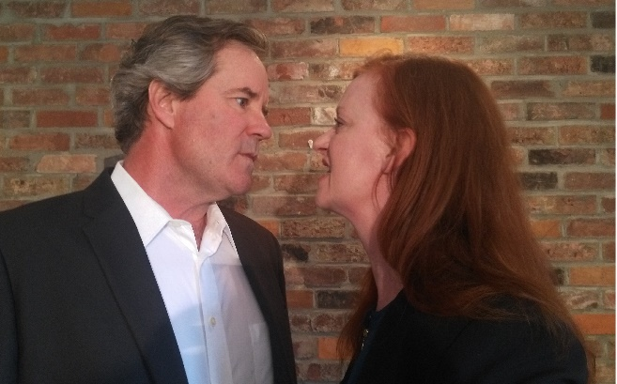
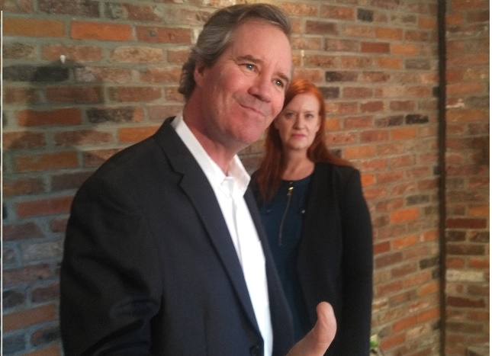

Red Haired Girl, picture 1  From left to right: Brian King, Regan Brown | Red Haired Girl, picture 2  From left to right: Brian King, Regan Brown
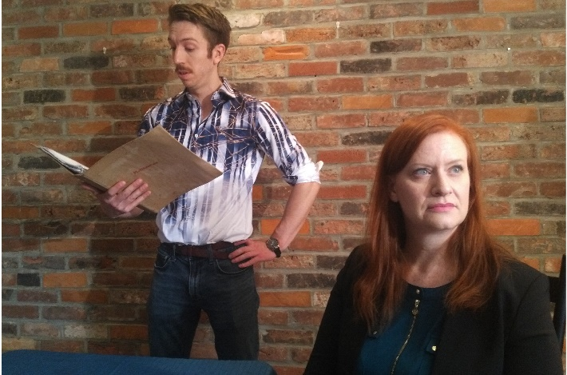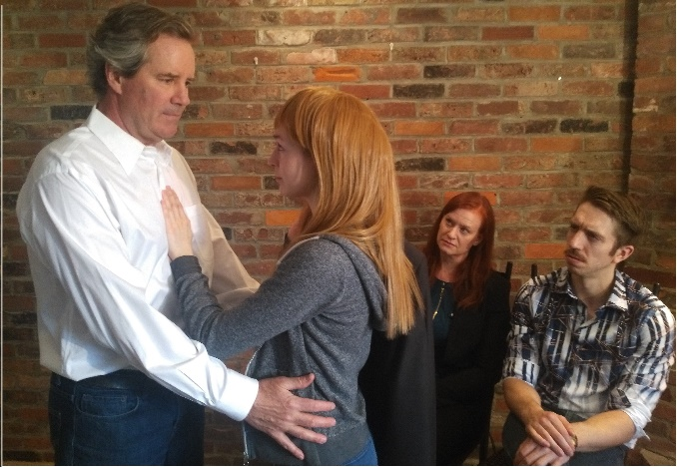
Red Haired Girl, picture 3  From left to right: Mike Wisniowski, Regan Brown | Red Haired Girl, picture 4  From left to right, Brian King, Jessica Bowmer, Regan Brown, Mike Wisniowski

